Bradfield Tennis Centre Tennis Assistants required

Job: | Coaching Team Member – Tennis Assistants
Salary: | £7.50 - £9.50ph depending on qualification and experience
Hours: | Approximately 10 hours per week
Reports to: | Director of Tennis
Location: | Bradfield College Tennis Centre, Bradfield, Reading. Berkshire RG7 6BZ

The Tennis Team and it’s values
Due to the high demand for 10& Under tennis and LTA Tournaments, Bradfield Tennis Centre are expanding their Coaching Team and are looking to recruit a small team of Tennis Assistants to add value and strength to an already strong and cohesive Coaching Team at our world class tennis facility.
The Centre boasts three indoor Plexi – pave courts (as used at the Australian Open) and six floodlit Conica clay courts (as used at the WTA Porsche Open in Stuttgart & the NTC at Roehampton)
Bradfield Tennis Centre is a multi – LTA Award winning Centre having won LTA Berkshire Club of the Year 2017 & 2018, LTA Berkshire and Regional Official of the Year 2020, LTA Berkshire Young Person of the Year 2018 & 2020, LTA Berkshire Performance Coach of the Year 2020 & 2021 and LTA Berkshire Competition of the Year 2018, 2019 & 2021
The foundations for these successes are based upon the Team’s six pillars:
- Strength
- Openness to learning
- Respect
- Professionalism
- Work ethic
- Ambition
The successful applicants will need to share and add value to these pillars and the Team’s values, such as:
- A Player centred approach
- Work with junior players regardless of their age and playing ability
- Professionalism on and off court representative of the Tennis Centre
- Open to learning from other team members
- A Team centred approach with the ability to build on and take on new ideas
- Self – improvement through CPD whether delivered in – house or externally
- Be flexible as the job role may require the successful candidates to occasionally work unsociable Hours
- Must be a true tennis fan

Job Summary
Key Responsibilities:
- Assist the Coaching Team with weekly 10 & under courses
- Court supervise 8, 9 and 10& Under LTA Tennis tournaments
- Assist the Tennis Development Officer with the running of LTA sanctioned competitions
- Set up courts for coaching session and tidy up afterwards
- Assist with day to day cleaning and maintenance of the clay courts and Indoor Centre

Person Specification:
- A tennis background, either having received coaching or played in LTA events
- Willingness to learn – CPD will be provided and possible funding towards LTA L1 & L2 for the right candidates
- Good IT background including knowledge of MS Office and Outlook
- A forward-facing team member willing to take responsibility
Additional Benefits:
- Basic hourly rate
- Subsidised Membership of Health Club
- Subsidised Membership of Golf Club
- Meal provided when working Saturdays
- Holiday entitlement
- Subsidised CPD – further development

All candidates are required to complete an application form.

Closing Date: 25/07/2022
Should you wish to discuss the position directly please call Damian Fuller, Director of Tennis: Tel: 0118 964 4566 / 07768508021 or email dfuller@bradfieldcollege.org.uk

For a Job Description and an Application Form please email recruitment@bradfieldcollege.org.uk or contact the HR Department: Tel: 0118 964 4546

The post-holder of this post may perform other related duties as negotiated to meet the on-going needs of the College, and due to the College continually evolving and progressing may be amended at any time, in conjunction with the post-holder, to allow for improvements to the levels of care and the protocols by which the College functions.

You should refer to your individual responsibilities as defined in the Health & Safety Manual and ensure you are competent to implement them and agree to abide by them. Your health, safety and welfare at work are protected by law. Your employer has a duty to protect you and to keep you informed about health and safety. You have a responsibility to look after yourself and others. If there is a problem, you should discuss it with your employer or the College’s Health, Security & Safety Manager.

Safeguarding
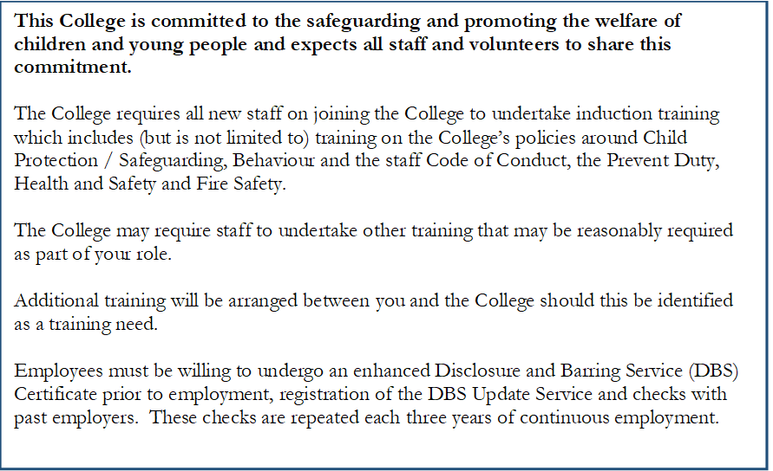

Disclosure and Barring Service, references and right to work in the UK
As Bradfield College is registered to ask ‘exempted questions’ under the Rehabilitation of Offenders Act 1974, successful applicants will be subject to the required and satisfactory DBS (Disclosure and Barring Service) clearances before the appointment is confirmed.
This post is also subject to receipt of written references which must be satisfactory to Bradfield College.
Successful applicants will need to provide confirmation of permission to work in the UK. Please note that under the Immigration Asylum and Nationality Act 2006, Bradfield College has an obligation to ensure applicants have the right to work in the UK prior to commencement of employment (this is carried out at the interview stage; if applicants fail to produce the required genuine documents prior to commencement of work for the College, or if it is found that those documents do not meet the legal requirement, an offer of employment will be withdrawn).

