

Bradfield College Head Injury Policy

Document Control
Document title: | Head Injury Policy
Author: | Pauline Kenyon RGN – Reviewed by Helena Nightingale
Version number: | 2.2
Document status: | Modifications to 2.2 approved by
Effective Date:
Reviewed:
Version number: | 2.2
Documentation Location | College Website /Medical Polices on Teams

Version | Author | Date | Changes
1.0 | J. Chapman | Oct 2018 | N/A
2.0 | P. Kenyon | Nov 2021 | Full review of safe practise standards in line with professional sports guidelines and BSA advice
2.1 | P. Kenyon | Dec 2023 | Re-wrote section 4 in line with national updates
2.2 | H. Nightingale | Jan 2026 | Literature review and reference update. Changes documented below:  -All minor head injuries are off games for 48hrs REMOVED  -Concussion symptoms present for 30mins or less are not put on the return to play pathway REMOVED  -Nurses and physios are expected to complete the initial review of pupil within 48hrs of injury onset  -The physio will then complete the follow up review on day 7, day 14 and day 22 post injury  -If parents would prefer doctor lead care they can access specialist care via return to play. Details in policy  -Gradual return to play pathway has been extended to 23 days (Concussion Guidelines for the Education Sector 2015)

1. Introduction

This policy is written for all members of Bradfield College staff. It’s aims are:
- To acknowledge the significance of concussion, however it occurs.
- To encourage an understanding both by pupils and staff that a return to sport too soon after a concussion injury carries significant risk to immediate and long-term health.
- To acknowledge that concussion can affect cognitive functioning for weeks after an injury, and to encourage staff to support affected pupils.
- To provide a protocol to follow to facilitate a prompt medical review if a pupil suffers a suspected concussion on school grounds.
- To provide a protocol to follow during the recovery phase to ensure that a pupil is appropriately managed to allow them to make a full and safe recovery.

2. Concussion

Concussion is a brain injury caused by a blow to the head or body which leads to shaking of the brain (Concussion Guidelines for the Education Sector (CGES). It does not require a loss of consciousness to be diagnosed – in fact, <10% of people with concussion present in this way. It can occur in any situation where there is the possibility of suffering a head injury – either a direct blow to the head or the head being shaken when the body is struck. Attention should be particularly paid to:

- High-impact sports
- Sports undertaken from a height (e.g., climbing)
- Sports carried out on a hard surface (e.g., cycling, tennis, fives)
- Sports involving a hard ball, bat, or racquet (e.g., cricket, tennis, lacrosse, fives)

Symptoms of concussion can first present at any time after the impact. It is important to realise that the signs and symptoms of concussion may only last a matter of seconds or minutes and can easily be missed.
Concussion must be taken extremely seriously to safeguard the short- and long-term health and welfare of pupils. Typically, most people recover from concussion over a period of days or weeks, although in some cases symptoms may be prolonged. A small minority turn into post-concussion syndrome, which can last for months and even years, so a conservative approach needs to be taken. This is considered in the guidance. There is good evidence that during the recovery period from concussion, the brain is more vulnerable to further injury.
If a pupil returns to sport before they have fully recovered and have further concussions this may result in:
- Prolonged concussion symptoms
- Possible increased risk of long-term health consequences e.g., mild cognitive impairment or (possible) degenerative brain disorders in later life (e.g., dementia. See ‘further information’).
- In adolescents, a further concussive event before recovery can in rare cases be FATAL, due to severe brain swelling. This is known as second impact syndrome.
The following pupils may all require a longer recovery period:
- Those with a history of a previous concussion within 12 months
- Those who have had a prolonged period of recovery from a previous concussion
- Those pupils who have Attention Deficit Hyperactive Disorder (ADHD)

3. Assessing the pupil
Please refer to flow charts below and Appendix 1 Head Injury Flow Chart from R2P summarising initial decision making as to whether the injury is a concussion or a mild head injury and actions which should be taken once diagnosis is made. Use of the concussion recognition tool advised. (Mc Crory et al. 2013)

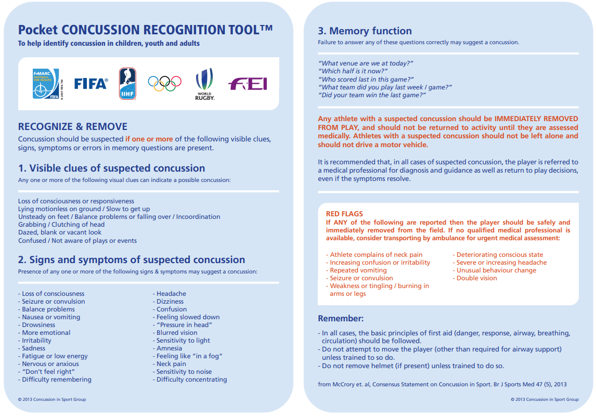

If a situation arises whereby there is a conflict of opinion as to the significance of a blow to the head, in the absence of a qualified medical professional, the Official in charge is the responsible decision-maker. He or she has the authority to remove the player from the game until they seek a medical assessment.
All Bradfield College staff, and other players, coaches, parents, matrons, teachers etc - have a joint responsibility to do their best to ensure that someone they suspect may have concussion, is removed from play in a safe manner. Any staff or spectators witnessing a pupil with a possible concussion attempting to continue playing, must inform the Official in charge as soon as possible to recommend the pupil seeks medical attention.

IF IN DOUBT, SIT THEM OUT

When a pupil is taken to the medical centre, a school nurse or physio will then carry out an assessment of the pupil’s symptoms and arrange the appropriate medical treatment:
If concussion is diagnosed, the pupil will follow the Rugby Football Union (RFU) Headcase guidance (2024) appropriate for their age:

4. Concussion timetable, including graduated return to play programme.

Time since Injury (Earliest Day) | Date | Activity Level | Exercise allowed | Objective
0-2 days |  | Relative rest | Including 1-2 days complete body and brain rest, if needed. No physical exercise; can travel with the team | Recovery
 |  |  | Medical assessment with nurse or physio to confirm diagnosis and give recovery advice
3-7 days |  | Light activity | Gentle walks etc. Activity shouldn’t leave the pupil breathless | To maintain low level fitness
8 days onwards |  | Low risk exercise & training | Gradual increase in self-directed exercise – light jogging for 10-15 mins, stationary bike, swimming, supervised weight training etc. Can introduce static training drills (e.g., passing/ kicking). Only drills with NO predictable risk of head injury. | Focus on fitness.
 |  |  | Nurse or physio to assess fitness-to-start a formal return to sport.
15 days onwards |  | Gradual return to sports training | Starting with non-contact and gradually building up complexity and intensity. Introduction of contact in the final stages (only when symptom-free at for 14 days) | Exercise, coordination and skills/tactics
 |  |  | Nurse or physio to assess fitness to return to unrestricted sport, including matches
Day 23 earliest |  | Earliest return to competitive sport/matches | Only if symptom free at rest for at least 14 days and has completed gradual return to sports training without any recurrence in symptoms | Return to competitive sports/matches

Pupils will be reviewed:
Day 0 The same day as the injury
Day 7 Before starting skills, drills and gentle jogging
Day 14 Before progressing dynamic activity
Day 22 Prior to being signed back on sport
This programme has been agreed across sports and reproduced as national guidelines for the Education Sector endorsed by the Department of Health and the Department for Education. It must be emphasised that these are minimum return to play times and in pupils who do not recover fully within these timeframes, these will need to be longer.
When a pupil completes each stage successfully without any symptoms, they will take 23 days minimum to complete their rehabilitation (this includes the 14-day rest period). If any symptoms occur while progressing through the Graduated Return to Play (GRTP) protocol, the pupil must return to the previous stage and attempt to progress again after a minimum 48-hour period of rest has passed without the appearance of any symptoms. If well enough, the pupil will then be moved up the protocol.
If the nurse / physio has any concerns at any point during the concussion pathway, she will speak to the GP or give the pupil a GP appointment. Once GRTP has been successfully completed this will be documented in their ISAMS notes, they will be taken off managed participation in sport and can now return to play. ISAMS documentation of their concussion care can be printed off and taken to any sports club to which they may belong, that is not associated with Bradfield College, to inform sports coaches where abouts they are on their care pathway.

5. Heading Advice for Football

Following government research and consultation in May 2021, new advice from England Football, states that: “It is recommended that heading practice is limited to 10 headers per session and only one session a week where heading practice is included. Players should be responsible for monitoring their own heading activity” file:///C:/Users/pauli/Downloads/youth-heading-guidance-chart.pdf

6. When No School Nurse or Physio is Available

If there is no school nurse or physio available or the incident happens off site, then the pupil should be assessed by a first aider, an accident report filled in on firefly and the pupil must see a school nurse or physio at the earliest opportunity. It is the first aider’s responsibility to decide whether or not the pupil requires further medical treatment, and in all cases the parents must be notified.

If a pupil has sustained a head injury at an event not related to the school, it is the parents’ responsibility to inform the medical centre so that appropriate care can be continued in school.

7. When To Refer On

It is advised that a pupil is referred on for specialist help either through their GP or via the private return to play doctors group if a pupil:

- Consider referring on if 2 or more concussions within 12 months
- Consistently fails to progress through the gradual return to play pathway
- Presents with symptoms which management strategies are beyond our scope of practice for example specialist vestibular rehabilitation to improve balance issues.

8. Further Information, Links and References

Concussion Guidelines for the Education Sector (CGES) – Updated 2015
Concussion-Guidelines.pdf

Rugby Football Union (RFU) – updated guidelines 2024
HEADCASE | Rugby Football Union

Medical Officers of Schools Association (MOSA) (This can only be accessed by members)
https://www.mosa.org.uk/

Alzheimers society - Some research does suggest traumatic brain injuries may increase the risk of dementia. However, there is still much more research to be done to understand this complex issue, particularly in relation to contact sports like football and rugby. (Article written April 2021)
https://www.alzheimers.org.uk/about-dementia/risk-factors-and-prevention/head-injury-sport-dementia

Adams, J., Frumiento, C., Shatney-Leach, L. et al. (2001) Mandatory admission after isolated mild closed head injury in children: is it necessary?. Journal of Pediatric Surgery 36(1): 119-21
Anderson, V., Rausa, V. C., Anderson, N. et al. (2021) Protocol for a randomised clinical trial of multimodal postconcussion symptom treatment and recovery: the Concussion Essentials study. BMJ Open 11(2): e041458
Echemendia R, Burma J, Bruce J et al (2023) SCAT 6 Concussion in Sport Assessment Tool British Journal of Sports Medicine 57 (11)
Ingebrigtsen, T.; Romner, B.; Kock-Jensen, C. (2000) Scandinavian guidelines for initial management of minimal, mild, and moderate head injuries. The Scandinavian Neurotrauma Committee. The Journal of trauma 48(4): 760-6#
Mc Crory et al. (2013) Consensus Statement on Concussion in Sport. British Journal of Sports Medicine 47 (5)
NICE Clinical Guidelines, Head Injury: Assessment and Early Management, CG232 Published 18 May 2023
Patricious J, Meeuwisse W, Schneider K, Consensus Statement on Concussion in Sport (2022) Journal of Sports Medicine (57) 11
Putukian M, Purcell L, Schneider K , et al (2023) Clinical recovery from concussion: return to school and sport: a systematic review and meta-analysis. Br J Sports Med
Tavender, E. J., Bosch, M., Green, S. et al. (2011) Quality and consistency of guidelines for the management of mild traumatic brain injury in the emergency department. Academic Emergency Medicine 18(8): 880-9

